ACCOUNT SERVER TO ENGINEERING SERVER
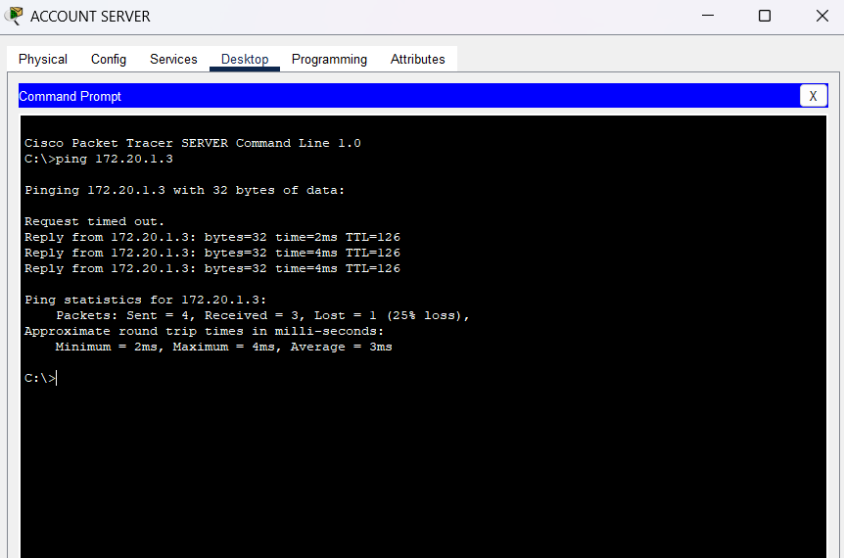

IT SUPPORT PC TO WIRELESS PC
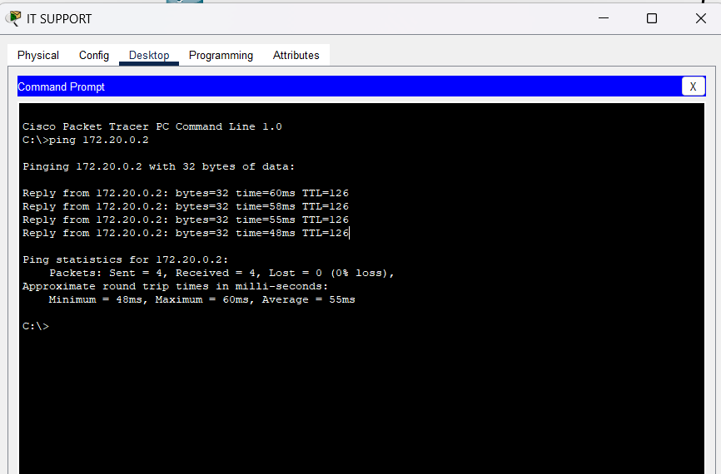

GENERAL SERVER TO DNS SERVER IP
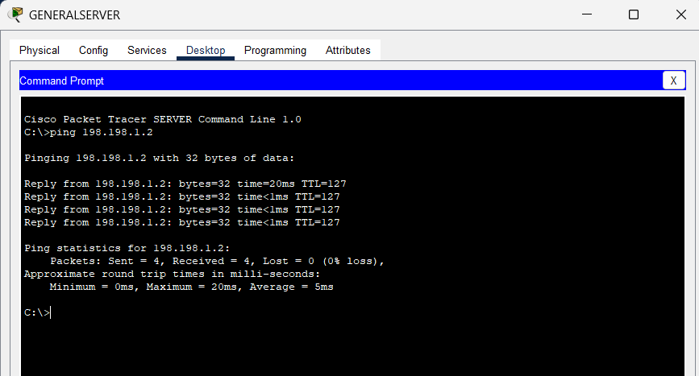

GENERAL SERVER TO WEB SERVER IP
